The Industrial Revolution - Agriculture
In order for a revolution in manufacturing technology to take place there had to be a certain number of essential prerequisites. Some are obvious:
- raw materials (coal, iron, wool, wood etc.)
- transport systems (rivers, canals, roads etc.)
- an available workforce (people in sufficient numbers and willing to adapt to new techniques of manufacture).
- a market (for without a large number of people ready to purchase what is manufactured there is little point in producing more).
- money(capital).
Ref: http://www.saburchill.com/history/Woodall/006.html

By the middle of the 16th century a new social class appeared in England, a social class that was unique in Europe, the land-owning middle class or "the landed gentry". They were unique in the sense that, whereas in the rest of Europe the land was still the property of the king or the traditional nobility whose incomes continued to depend upon taxing the peasants in the traditional way, this new breed of landowners in England had every intention of using its newly-acquired land to make a profit.

Land was "enclosed", or fenced off, in order to permit the raising of enormous herds of sheep because of the profit obtained from their wool, but the first major consequence was the forced removal of hundreds of thousands of peasants from their land.

Leading up to the industrial revolution, the key change was Enclosure, a change in how the use of agricultural land was organized
- key to agriculture becoming more efficient
- land ownership:
  - the owners of the land were rich upper class families
  - they leased the land to villages whose residents cooperated to farm communally but different families has the right to the produce of different amounts of land
  - during enclosure the landowners wrote new leases to individual families--often 19 year leases
  - every family in that village had the right to get a lease for an amount of land equivalent to the rights they had before
- the replacement of communal farms with family farms was well underway before the industrial revolution--started on the basis of agreement of villagers but was increasingly forced after 1760
- communally farmed land and common land were divided up into family farms, each family getting an equivalent share to what they had before
- people who got very small farms couldn't survive on their own without the right to use the common (because it has been divided up too) and had to sell out, so farms got larger (several hundred acres)
- family farms (on leased land) worked by the family and some hired agricultural laborers (at first fairly often hired on an annual basis)
- this was key because it gave opportunities to those farmers who were interested in improving--they could invest in improving their land or new crops
- End result of this process of enclosure & farms getting larger was a pattern of large family farms on land leased from an upper class landowner:
  - Farms of 200-500 acres
  - One family held the lease and makes decisions
  - That family could invest in improvements and get profits
In the late 18th century (at the start of the industrial revolution):
- 15-20% of the land was owned by the farmers themselves, 75% by large landlords, usually the old aristocracy whose families had owned the land for many generations
- farmers did often have 19 year leases--farm size refers to the size of the farm a family leased and managed, not the land owned by a landlord
- the small farmers who sold their land rights mostly become agricultural laborers but some moved to cities
- the overall labor surplus kept wages down
- in a few areas people were moved off the land to increase pastureland for sheep
- it is somewhat oversimplified to say that poor people moved from rural areas to the cities and provided the labor force for the industrial revolution
- but agriculture certainly made a difference because it allowed population increases and fed an increasing population of city-dwellers
Rural Poor:
- even before the industrial revolution there were leaseholders who controlled land and laborers who had no land rights and worked for money (or food)
- enclosure benefits the remaining leaseholders, but more people become laborers
- before the industrial revolution, farm workers had been hired annually and fed by the farmer, as the industrial revolution developed the system changed, farm laborers were hired when needed and paid weekly wages
- why? disappearance of feudalism, more emphasis on profit
- the system of relief for the poor--poor laws--was based on the idea you could only get help in the place where you were born
- population began to grow more rapidly, more food
- the poor had large families because more children meant more wages and with the early poor law reform called the Speenhamland System, actual cash benefits
- Hobsbawm writes about the Speenhamland system, which made the situation worse by encouraging people to have more children and providing benefits only if they stayed in the parish where they were born (discouraging them from moving to find work)

Agricultural Revolution
The Agricultural Revolution got its start in Great Britain in the early 18th century and spread throughout Europe and America by the 19th century. This was a period of significant agricultural development marked by new farming techniques and inventions that led to a massive increase in food production. The Agricultural Revolution brought about experimentation with new crops and new methods of crop rotation. These new farming techniques gave soil time to replenish nutrients leading to stronger crops and better agricultural output. Advancements in irrigation and drainage further increased productivity.

Inventions of the Agricultural Revolution
It was also during this time that inventions were created that greatly increased efficiency. The Agricultural Revolution saw the invention of the plow, which is a device that contains blades that effectively break up the soil. Plows created cuts within the soil for the sowing of seeds. Before the invention of the plow, and another device called a seed drill, seeds were sown by hand, which was inefficient and led to many seeds failing to grow. A seed drill is a machine that plants seeds in uniform rows and then covers them.
Jethro Tull was an 18th-century agriculturist who invented the seed drill. You may be familiar with the band by the name of Jethro Tull that was popular during the 1960s and 70s. This band got its name from a booking agent staff member who was also a history enthusiast; he suggested the name and the name stuck.
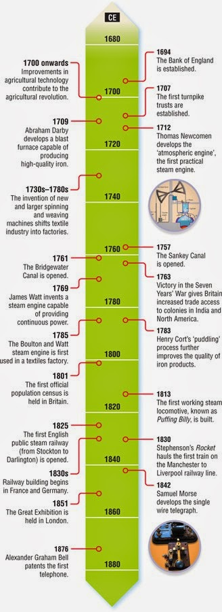
Now, the Agricultural Revolution also saw the invention of the reaper, which was a machine for cutting and harvesting grain. An American inventor named Cyrus McCormick is credited with mass production of the reaper, which saved many back-breaking hours of labor in the fields. These inventions, and others, made farming easier, less time consuming and made large-scale agricultural production possible. These agricultural changes created a ripple effect that spread throughout society, with one of the more notable results being a rapid increase in population.
The Agricultural Revolution was also instrumental in the early development of cities. Because fewer workers were needed on the farms, and there was su

Link to History Resources
http://www.saburchill.com/history/Woodall/006.html
‘Not-for-profit use of Open Door Web Site images
Any student has permission to use any of the Open Door Website original images in his/her assignments. This includes word processing, PowerPoint presentations and web sites. The ODWS team only asks that you credit the image and link back to the Open Door Web Site (© ODWS www.saburchill.com)
All of the images copyrighted to the ODWS may be used for general not-for-profit publication with prior permission from the ODWS webmaster. This includes printed material, websites and PPT presentations. The ODWS team asks that you credit the image and link back to the Open Door Web Site (© ODWS www.saburchill.com)

